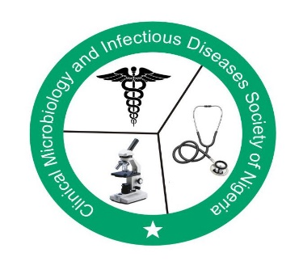
CLINICAL MICROBIOLOGY AND INFECTIOUS DISEASES SOCIETY OF NIGERIA (CLIMIDSON)
The first (virtual) annual scientific conference of CLIMIDSON - 26th and 27th of November 2020 :
“Antimicrobial Stewardship: Time to move from Theory to Practice”.
Speakers were drawn from within and outside Nigeria, including Kenya, South Africa, Belgium, and the USA.

The opening ceremony was chaired by Prof. Vincent O Rotimi of the College of Medicine of the Lagos State University. In his opening remarks he expressed his excitement about the prospects of expanding our horizon in best medical practice by starting such a conference that would become an annual event in the country and the region. He commended the multidisciplinary composition of the organisation and participants at the conference.

In her keynote lecture, Prof Folasade Ogunsola, Deputy Vice Chancellor, Development Services and former Ag Vice Chancellor of the University of Lagos gave a highly informative exposé on antimicrobial stewardship: time to move from theory to practice. The subject was excellently presented and featured important salient points on the goals of Antimicrobial Stewardship (AMS) among which improvement of patient outcome, safety, reduction of antimicrobial resistance (AMR) and reduction of healthcare cost through judicious use of antibiotics. Effective and successful AMS programs require sincere leadership commitment, prescriber accountability, drug expertise, education of physicians and patients and additional resources such as hospital personnel and equipment. She also highlighted the interface between AMS and Infection Prevention and Control (IPC) and the need to adapt all policies and guidelines to local situations. She bemoaned the low level of support for AMS from hospital managements and key health officials but blamed it on the poor communication between these leaders and the practitioners and called for a closer collaboration between all stakeholders.

The president of CLIMIDSON, Dr Kenneth C. Iregbu of National Hospital Abuja, noted that the society choose the year’s theme because of escalating prevalence of antimicrobial resistance (AMR) and the need for practitioners to be conscious and introduce preventive measures in their daily practice. He expressed the desire to see most hospitals, especially tertiary hospitals in the country improve on their AMS status beginning from the end of the conference; using lessons learnt. During the first workshop “The State of Antimicrobial Stewardship in Nigeria”, he presented the results of a survey on the gaps and challenges in AMS practice in Nigeria carried out in 20 hospitals in Nigeria. Only 30% of tertiary care hospitals had AMS committees and they neither have policies, guidelines nor hold regular meetings. Although all the 20 hospitals have adequate laboratory facilities and manpower to support AMS, the laboratories were largely underutilized. Either a core or supplemental AMS strategies has been implemented in three hospitals in the country. Prof Aaron Aboderin of Obafemi Awolowo of University Teaching Hospitals Complex gave an overview of the Action plan on AMR for Nigeria, while Dr Nubwa Medugu presented a mini surveillance of Staphylococcus aureus resistance in Nigeria, which showed an MRSA prevalence of 49% and vancomycin resistance of 1.3% across the country. Prof Oyinlola Oduyebo, the Vice President of the Society and the Coordinator of the National Antimicrobial Stewardship Working Group of the society, presented a paper on recommended guidelines for AMS, based on the experience of hospitals that participated in the global point prevalence of antimicrobial consumption and resistance in Nigeria between 2015 and 2018.

Three papers were presented at the second workshop on” Antimicrobial Stewardship: Getting Started” highlighting the need to start AMS at the hospital based on availability of resources. Dr Princewill Nwajiobi-Princewill emphasized the importance of the AMS Committee and the need to have a multi-disciplinary team of committed members. He also stressed on the qualities of the team’s leadership, which amongst others must include integrity, knowledgeability , commitment, command of influence, sufficient respect by members of the community. Dr Philip Oshun dwelt on the need to start from the low hanging fruits such as intavenous to oral switch, antibiotic time-out, dose optimization, surgical antimicrobial prophylaxis and education of prescribers and healthcare personnel. All these could be carried out with little resources as often encountered in low – and middle-income countries (LIMCs).
Dr Stella C. Osuagwu highlighted on how Global-PPS data were used to engage prescribers in Lagos University Teaching Hospital, culminating in the production of antibiotic guidelines by the paediatrics department, and the eventual adoption of prospective audit, intervention, and feedback as their AMS core strategy. Her presentation showed how they were able to train clinical students to effectively participate in the daily data review, thus bridging the manpower deficiency. A monthly review/evaluation over a six-month period revealed a 59% cumulative compliance with guideline and 59.3% of appropriate prescription, and Trends in overall compliance with ASP recommendations showed a steady increase (35.3% in month 1 to 54,2% in month 6).

The third workshop was devoted to Developing Antimicrobial Policies and Treatment guidelines. Prof. Marc Mendelson of the University of Capetown South Africa and Dr Moses Masika of the University of Nairobi, Kenya presented papers emphasizing on practical approaches to developing effective and practicable policies and guidelines. Dr Masika Shared the experience of Kenya in the development of its National Antimicrobial/AMS policy. Both speakers stressed on the importance of involving all Stakeholders in policy and guideline development. It is only then they can own and put them into action.

From most presentations, it was clear that clinical microbiologists and other stakeholders in Nigeria have embraced the Global-PPS and have found it a useful tool to drive AMS in the country; no wonder the fourth workshop was devoted to Global-PPS, and the presenters drawn from the Global-PPS base at the University of Antwerp, Belgium. Ann Versporten and Ines Pauwels vividly presented the approach to the use of the Global-PPS tool and its usefulness. The tool enables users collect data on antimicrobial therapy, as well as the demographics of the patients and antimicrobial prescribing patterns by doctors. It also provides opportunities for data on hospital acquired infections. Data submitted to the central collation and analysis system from Nigeria from 2015 to date were presented to demonstrate the robustness of the tool.

In the fifth workshop, Global-PPS data derived from hospitals in Nigeria were presented. While Dr Chukwuma D. Umeokonkwo showed longitudinal results from 2015 to 2018 across institutions, others presented centre-specific data from 2019 and 2020. Overall, results revealed the persistence of poor quality of prescribing, though with isolated minor improvement, poor utilization of microbiology laboratory, extensive use of antibiotics from the Watch list for empiric therapy and general lack of antibiotic guidelines in the various hospitals.
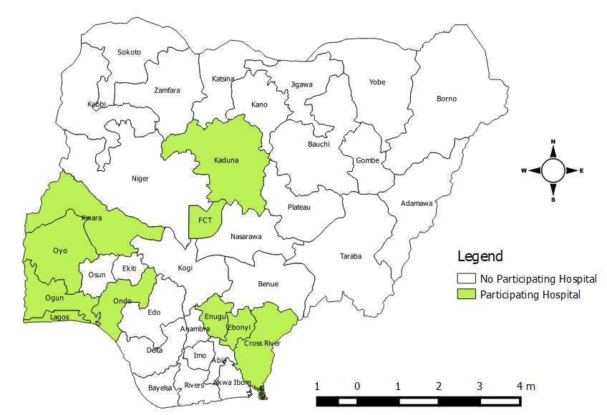
The different Nigerian states participating to the Global-PPS (N=19 hospitals)

The possible impact of the COVID-19 pandemic on AMR did not escape the attention of the conference organisers, and it was made the subject matter of workshop six. The implication of COVID-19 pandemic on AMR was elaborated by Dr Adeola Fowotade of the University College Hospital Ibadan. She reviewed the possible reasons for the introduction of antibiotics into the COVID-19 therapy menu. She concluded that inappropriate prescriptions occasioned by the pandemic is likely to impact negatively on AMR prevalence and suggested the restriction of such use to severe cases, supported by local laboratory antibiogram, implying that AMS principles apply in managing covid-19 patients.

Prof Ben Nwomeh of Surgery and Vice-Chair of global surgery at the Ohio state University Wexner Medical Centre, and Dr Titi Afolabi, an assistant Professor of pharmacy at the Midwestern University college of Pharmacy, Glendale, Arizona nicely presented on the critical roles of advocacy, education, and training in the success of AMS during workshop 7. Again, they emphasized the need to involve all stakeholders and to define roles in the establishment of the AMS committees and the development of policies and guidelines. They also stressed the need to regularly educate and re-train members of the committee and the stakeholders, particularly the prescribers.

During two oral abstract presentation sessions, papers included “longitudinal antibiotic point prevalence survey to drive antibiotic stewardship” by Dr. P. Nwajiobi-Princewill; “Pattern of antibiotic uses and resistance phenotypes in medical wards of a tertiary health facility in Lagos” by Dr C. Idakari; “The use of whole genome sequencing to characterize a multidrug resistant strain of Klebsiella pneumoniae” by Dr S. Aliyu; “The clinical and economic impact of inappropriate antimicrobial therapy on patients admitted in the medical ward of Lagos University Teaching hospital” by Dr I Otaigbe; “Pseudomonas species antibiogram: An important tool in combating antibiotic resistance for better patient safety in Gombe, Nigeria” by Dr M. Ibrahim; and “Antimicrobial Use and Resistance Surveillance in Paediatrics Development of Lagos University Teaching Hospital” by Dr O. Ola-Bello.

To conclude, the conference was highly informative and educative demonstrating the important role of the Global-PPS tool in driving antimicrobial stewardship. Nigerian practitioners involved in AMS have indeed found synergy with Global-PPS.

Report as complied by Dr K.C. Iregbu

